Commands:

1. Navigate to the project directory

cd projects

2. Initialising git

git init .

git init

3. Create a repository on Github:

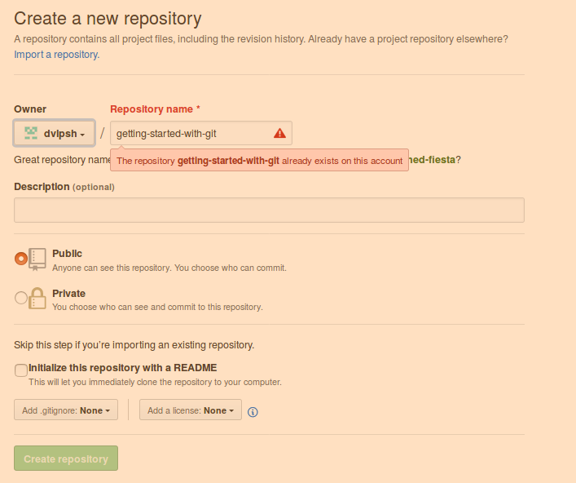

4. Add files to the staging area.

git add .

(Adds all files, you can also specify names of the files you want to add. Example

git add project.txt readme.md stars.py etc.)

5. Then follow the following screenshot:

a. To “create a new repository on the command line”, follow the commands one after the other.

b. To “push an existing repository” follow the second part.

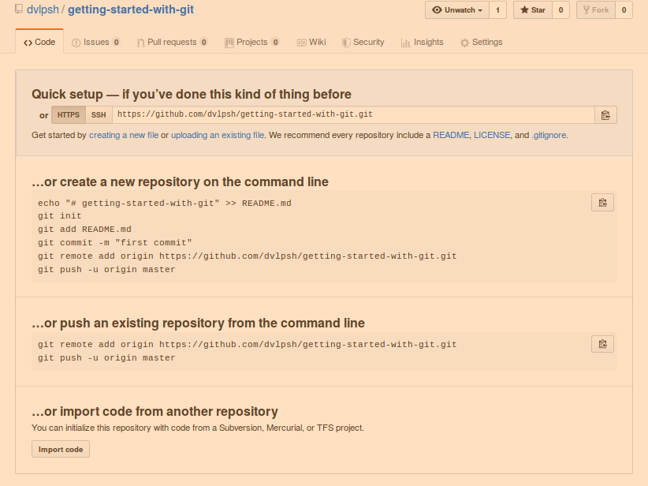

6. Refresh.